Name: ____________________________________

NetID: ____________________________________

Discussion section: __________________________

**Linguistics 1010 – Week 8**

**Make-up assignment**

1. Consider what Johnson and Newport (1989) found in their study of US immigrants who arrived in the country at different ages (every subject in the study had the same amount of exposure to English, the same motivation to learn English, and the same amount of instruction in English).

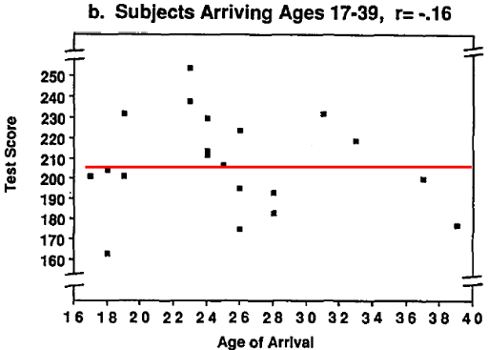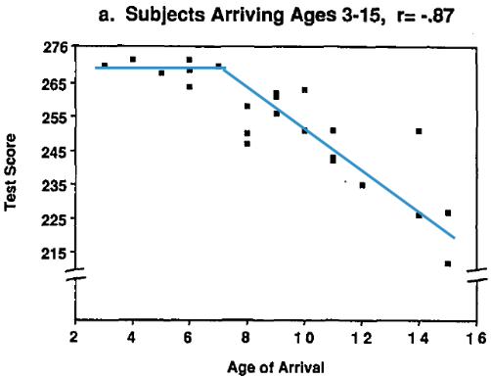

Focusing on the correlation between ‘Test score’ and ‘Age of Arrival’, explain why this result could be one piece of evidence for the critical period.

1. For this question, we will compare these three case studies of individuals who were isolated without language input.

* **Isabelle** lived in a dark room with her deaf (and mute) mother until age 6, when the mother managed to escape.
* **Genie** lived tied to a chair in a darkened room, with no interaction with other humans, until she was discovered at age 13.
* Though **Chelsea** was from a loving home, she was a partially deaf woman incorrectly diagnosed

as cognitively disabled. She was discovered at age 31, and fitted with a hearing aid.

After they were discovered, all three were taught English.

Among the three of them, who do you think most successfully acquired language, and who do you think was least successful? Explain why using the theories we learned in class.

1. Here are two possible theories of head movement in English.

* Move first theory: Move the first ***is*** (non-structure dependent transformation).
* Move matrix IP theory: Move the ***is*** that is in the matrix IP (structure dependent transformation).

A. For each of the following sentences, tell us which theory or theories can explain the existence of the sentence.

1. ../Screen%20Shot%202017-10-15%20at%204.52.12%20PM.pngIs Bill <is> trying to fix the car that is broken?
2. ../Screen%20Shot%202017-10-15%20at%204.52.12%20PM.pngWas John <was> angry because Mary was absent?
3. ../Screen%20Shot%202017-10-15%20at%204.53.54%20PM.pngIs the man who is drunk <is> happy?

To see how children could learn the correct theory of head-movement, we can look at two facts, the corpus facts and the experimental facts as shown below:

The corpus fact: Legate and Yang (2002) looked at over 20,000 questions that were spoken to a child in the CHILDES database, and they found that children do not seem to ever hear sentences that would suggest that “move first” is wrong. In other words, all of the sentences in the corpus are compatible with “move first” theory.

The experimental fact: Crain and Nakayama (1987) performed experiments to try to get children to produce yes-no questions in an attempt to see if they ever used the “move first” theory… and they found no mistakes that would suggest that children ever entertain the “move first” theory.

B. Why are the two facts above problematic for learning the correct theory of head-movement?

C. Explain how the facts above provide a possible argument for the modern nativist approach to language acquisition.

1. Mark each of the following statements as True or False. If false, explain why.

(a) The grammar of the pidgin is a simplified compromise mix of grammatical

properties of the contributing languages.

(b) There are native speakers of pidgins.

(c) Creoles shows more variation than the pidgin from speaker to speaker in terms of both word choice and grammar.

(d) Both pidgins and creoles have regular rules for phonology, morphology and syntax.

1. Consider the sentences in Hawaiian Creole English (HCE) (from the Hawai’i Tribune Herald 1946).
2. Mai bruhda nat skini.
3. Ai chrai fo kaech om.
4. Haed dis ol grin haus.
5. Da kaet ste in da haus.
6. Da kaet ste iting da fish.

|  |  |  |
| --- | --- | --- |
| Rules of HCE | HCE | GAE |
| **nat** (not) can be used with an adjective without the word “is”. |  |  |
| Events in progress may be indicated in three different ways:  by **ste** (stay) before the verb either with or without the *-ing* ending, or just by the verb with *–ing*. |  |  |
| **Haed** (had) is used for 'there was/were'. |  |  |
| Where GAE would use the word ‘to’ after a verb, HCE uses the word ‘**fo**’. |  |  |
| Sentences giving a location use the word **ste** (stay). |  |  |

In the table, there are five grammatical properties of HCE. Find the relevant HCE examples in (a)-(g) for each rule. Also, try to provide the General American English (GAE) translation.

6. Given that HCE sounds so similar to General American English (GAE) as shown above, many people often incorrectly believe HCE is a sub-standard form of English. Explain in your own words why HCE is a full human language with a complex grammatical system just like General American English.